**R16-7DB**

**Long-range UHF electronic tag reader**

**Instruction manual**

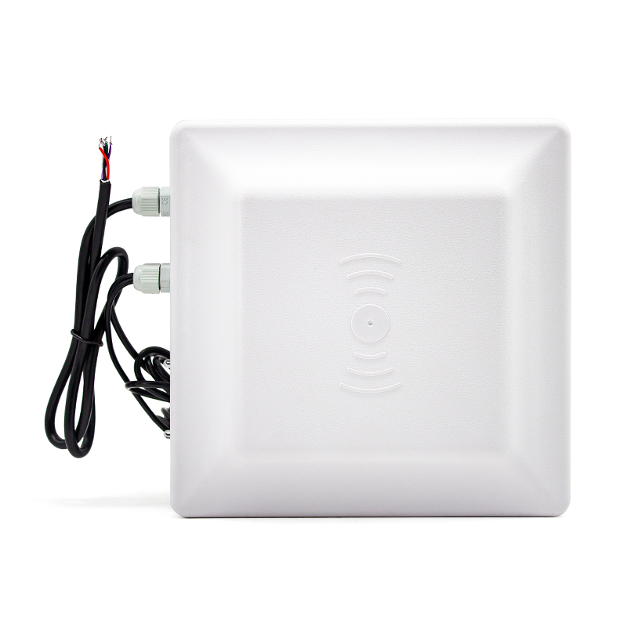

Directory

I. Introduction 2

1. Technical parameters 2

2. The size structure of the reader 3

3. Reader use 4

4. The main functions of the reader 4

Ⅱ. the working mode and wiring instructions of the reader 6

1. Wiring instructions of the reader 6

2. Label operation 6

3. Working methods 7

4. ID adjacent discrimination 7

Ⅲ. the reader configuration 7

Ⅳ. Installation of readers 8

1. Installation method of reader 8

2. Fixing and height adjustment of the reader 9

3. Reader azimuth adjustment 9

4. Installation example - vehicle parking lot management 10

I. Introduction

1. This product has multi-protocol compatibility, fast reading rate, waterproof appearance design, to meet the requirements of harsh working environment
2. Full support for ISO-18000-6C (EPC G2) compliant electronic tags;
3. Support USB, RS232 and Wiegand26/34 and other communication methods;
4. The output power is adjustable up to 30dBm, and supports a variety of working modes such as timing mode, master-slave mode, and trigger mode;
5. Applications are suitable for: vehicle access control, automatic toll collection without stopping, personnel access control management, logistics monitoring, production automation management and other fields

1. Technical parameters

|  |  |
| --- | --- |
| Operating frequency | Standard configuration ISM 902~928MHz or ISM 865~868MHz optional, can be customized other frequency bands |
| Antenna gain | Built-in circularly polarized antenna with 7dBi gain |
| agreement | ISO18000-6C（EPC G2） |
| Development kit | SDK development packages are provided, and C#, VC, VB, Java, Delphi development routines are provided |
| Software | Provide test DEMO and automatic card writing and reading DEMO to facilitate customers to issue and write cards |
| Output power | 0~30dBm, software adjustable |
| Communication interface | N型:Wiegand26/34, RS232/RS485, USB  E型:Wiegand26/34, RS232/RS485,TCP, USB |
| Input interface | 1 trigger input |
| How to read the card | Timing automatic card reading and external trigger control card reading, set by the software |
| Card reading speed | Set by the software, the average reading time of a single card is less than 6ms per 64bits |
| Read distance | 0-5 m (high power 0~8m) (reading distance is related to the tag and the site environment). |
| Operating temperature | -40℃~+65℃ |
| Storage temperature | -45℃~+95℃ |
| Power requirements | DC12V,3A |
| size | 215mm×215mm×50mm |
| weight | 0.8 kg (1.8 kg with packaging). |

2. The size structure of the reader

Unit: mm



3. Reader use

It can be used for item identification and data collection, taking advantage of its good characteristics, especially in the following fields can be widely used:

1. Transportation management: road and railway transportation management and container transportation management;
2. Motor vehicle management: public security, traffic and other departments to monitor and manage various motor vehicles;
3. Road and bridge tolling: Because this product has the ability to read tag data at long distance and high speed, road and bridge toll collection can be carried out without stopping;
4. Customs clearance management: customs clearance, customs transfer materials and vehicle management;
5. Warehousing and logistics management: commodity flow and warehousing management, as well as mail, parcels, air luggage, etc.;
6. Parking lot management: realize management and charging automation;
7. Access control management: including the entry and exit management of vehicles and personnel;
8. Process production process: monitor parts throughout the production process;

4. The main functions of the reader

* 1. Wake-up tag: Only the awakened tag can communicate with the reader, prevent the interference of other tags outside the system, and ensure the reliable and accurate information exchange between the reader and the system tag.
  2. Read tag data: not only the ID number of the tag can be read, but also the data of the specified tag storage area; Data can be read not only from a single tag, but also from multiple tags within the antenna wave range at the same time.
  3. Write label data: You can write data to the specified label store.
  4. It can be directly connected to control devices with standard Wiegand26/34 interfaces, without development and easy to use.
  5. Connect with the controller or PC through the standard communication interface for data communication and exchange; SDK development packages are provided for users to further develop applications.
  6. Precautions for use
     + 1. R16 series readers are generally connected to computers through RS232 data interface for data exchange. Since the R16 series reader can only read and write the electronic tag after receiving the control command of the controller, we will provide customers with SDK development kits, which users can use to develop application software.
       2. The working temperature of the reader is: -40°C~+65°C. Therefore, when using this reader in cold areas and seasons, attention should be paid to turning on and warming up in advance 15 minutes before the reader is officially used to ensure the normal operation of the reader.
       3. It is recommended that during the test, do not have any objects within at least 30 meters in front of the reader; When holding the card, please touch the two edges of the card with your fingers, because this antenna is horizontally polarized, the card should be placed horizontally facing the reader during the test to ensure the card reading effect.
       4. The Wiegand communication interface must be connected to GND ground.
       5. THE INSTALLATION HEIGHT IS MORE THAN 1.8M, AND THE POLE DIAMETER IS 30-50CM.
  7. Installation diagram

 

Pole diameter 30-50mm

Ⅱ. the working mode and wiring instructions of the reader

1. Wiring instructions of the reader

|  |  |  |  |  |  |
| --- | --- | --- | --- | --- | --- |
| red | black | green | white | grey | purple |
| DC+(7-12V) | GND | RX | TX | InG-D1 | InG-D 0 |

2. Label operation

**EPC GEN2** (**ISO18000-6C**) label

* Single label initialization: defines the EPC length of the tag, usually 96 bits.
* Single-tag write: Writes to the EPC of the tag, and can write one address or multiple addresses at a time (based on one address).
* Single Label Lock: Lock the EPC of the tag. Once locked, the label's EPC cannot be overwritten.
* Single label destruction: Destroys the label. Once destroyed, the tag can no longer be used.

3. Working methods

1. **MASTER-SLAVE WORKING MODE (COMMAND):** IN THIS WORKING MODE, THE READER WORKS UNDER THE CONTROL OF A PC OR OTHER CONTROLLER. Communication between the reader and the controller can be via one of RS232, RS485 or Ethernet interfaces. This way of working supports all the features provided by the secondary development package.
2. **TIMING READ:** THE READER AUTOMATICALLY READS THE CARD IN A CERTAIN PERIOD (CONFIGURABLE), AND THE READ DATA IS OUTPUT THROUGH THE SPECIFIED COMMUNICATION PORT. This mode is read-only for tag operations.
3. **TRIGGER READ:** WHEN THE INPUT LEVEL IS LOW ON THE TRIGGER INPUT PORT, THE READER STARTS TO READ THE CARD PERIODICALLY, AND AUTOMATICALLY TURNS OFF AFTER A PERIOD OF TIME.

4. ID adjacent discrimination

ID neighbor discrimination is designed to reduce the redundancy of data uploaded by the reader. When this function is selected, when the reader reads the card number of the same label multiple times in a row, only a set of data will be uploaded within the set time. The neighbor judgment can select the effective time, that is, if the interval between two adjacent card readings exceeds the valid time, they will not be judged by neighbor. Users should choose according to their specific needs. Commonly used in Wiegand communications.

Ⅲ. the reader configuration

The company provides DEMO software program for configuring the working parameters of the reader. The parameter configurator interface is shown in the following figure:

For the use of DEMO software, please refer to the "UHF Setting Software Manual"

Ⅳ. Installation of readers

1. Installation method of reader



Back of the reader

Install the clip

bracket

There are two types of reader bracket installation: "side 1-shaped installation" and "L bracket installation" are shown in the figure below: the installation method can be selected according to the application needs and the actual situation on site. Under normal circumstances, the side-mounted reading and writing distance is closer, but the installation is simple; The top-mounted method has a longer reading and writing distance, but it is complicated to install.

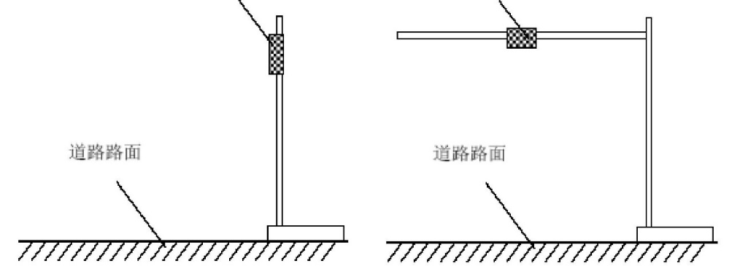

Reader side 1 shape installation Reader L shelf type installation

2. Fixing and height adjustment of the reader

When the zigzag stand is installed on the side, the mounting pole diameter of the R16-7 DB reader is required to be 3 0~50mm and the length is 2.2m It is best to use stainless steel materials with wall thickness greater than 1.2mm. Use the fasteners provided in the R16-7 DB reader box to secure the reader to the top of the pole. According to the vehicle type (mainly refers to large cars and small cars), adjust the height from the center of the R16-7 DB reader to the level of the lane, generally about 2.0m (1.8~2.2m). ）。

When installing the top of the L-shaped stand, it is required to install the diameter of the L-shaped stand pole (or gantry shape) and the diameter of the crossbar 30~50 mm It is best to use stainless steel materials with wall thickness greater than 1.2~2.0mm. The R16-7 DB reader is also secured on the crossbar near the middle of the lane using the own fasteners in the box. The height of the crossbar from the ground is adjusted between 3.5m~4.0m according to the height of the vehicle.

3. Reader azimuth adjustment

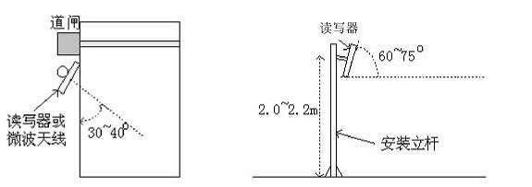

Antenna depression angle: refers to the angle between the antenna inclination to the ground and the horizontal line, about 60~75°

Antenna azimuth: refers to the offset angle of the antenna bias to the direction of the lane, about 30~40°

4. Installation example - vehicle parking lot management

The guidelines for choosing the installation location of the R16-7 DB reader system are:

1. The straight-line distance between the R16-7 DB reader and the barrier gate should not exceed 1 meter
2. There is nothing obscuring the location of the R16-7 DB reader and the label card
3. The R16-7 DB reader is as close as possible to the control equipment (or PC), and the specific on-site installation and implementation of shielded communication cables is generally determined according to the site conditions This is explained below.
   1. On-site installation method 1: the road has no intermediate separation of safety islands, road control equipment (barriers) are installed on both sides of the road, and vehicles pass through the card reading area at a speed of less than 30 km / h.

In this case: the reader (antenna) is required to be close to the barrier equipment, and at the same time make its effective range of reading tags (the longest straight line distance is 0.5 meters ~ 8 meters) can cover the inlet ground induction coil or outlet ground induction coil at the entrance and exit, as shown in the figure below.

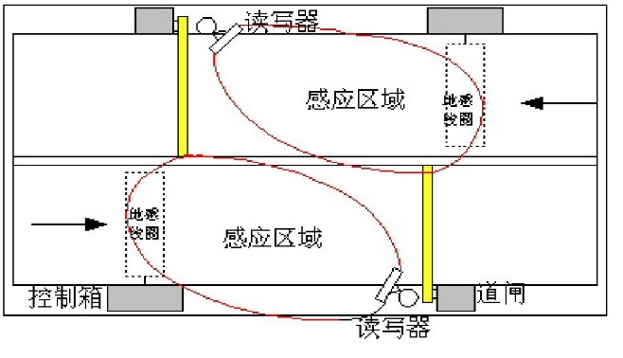

* 1. On-site installation method 2: the road has a safety island isolated in the middle, the control equipment (barrier) is installed on the safety island in the middle isolation, and the vehicle speed is less than 10 km / h through the card reading area.

In this case: it is required that the R16-7 DB reader should be close to the barrier equipment, and at the same time make its effective range of reading tags (the farthest straight line distance is 0.5 meters ~ 8 meters) to cover the inlet ground induction coil or at the entrance Outlet ground induction coil, as shown in the figure below.

